Document Adoption Flow Training
Sales document flow: A → U → L → R
Purpose
This document explains how to adopt sales documents in proalpha from quotation to sales order, delivery note, and invoice. It also summarizes the basic A/U/L/R document types and the linking concept used to trace document relationships.

1. Quick Reference: Sales Document Types
A  Angebot  Quotation | → | U  Auftrag  Sales Order | → | L  Lieferschein  Delivery Note | → | R  Rechnung  Invoice
Code | German Term | English Term | Meaning in the Flow
A | Angebot | Quotation | Initial offer created for the customer.
U | Auftrag | Sales Order | Order created by adopting the quotation.
L | Lieferschein | Delivery Note | Delivery document created by adopting the sales order.
R | Rechnung | Invoice | Billing document created from the delivery note or another allowed source.
G | Gutschrift | Credit Note | Credit document; not part of this main training flow.

2. Key Concepts Before Starting
- The standard sales flow is A → U → L → R: Quotation → Sales Order → Delivery Note → Invoice.
- Document adoption (Belegübernahme) copies header and position data from a source document into a target document.
- The main sales tables are V_BelegKopf for document headers and V_BelegPos for document positions.
- The origin reference (Herkunft) connects adopted positions back to the source document using source document type, reference number, and position number.
- Always verify item numbers, quantities, open quantities, storage location, and price information after adoption.
Important note before invoicing
The delivery note (Lieferschein) must be printed before it can be adopted to an invoice using Faktura nach Lieferschein.

3.Main Process: Quotation to Invoice
This section follows the full process from quotation creation to invoice creation.

3.1 Create a Quotation (A - Angebot)
Step 1: Create a new quotation
Create a new quotation (Angebot). Enter the customer, dates, responsible person, language, price list, delivery terms, and delivery information.
Check: The quotation header contains all required customer and commercial information.
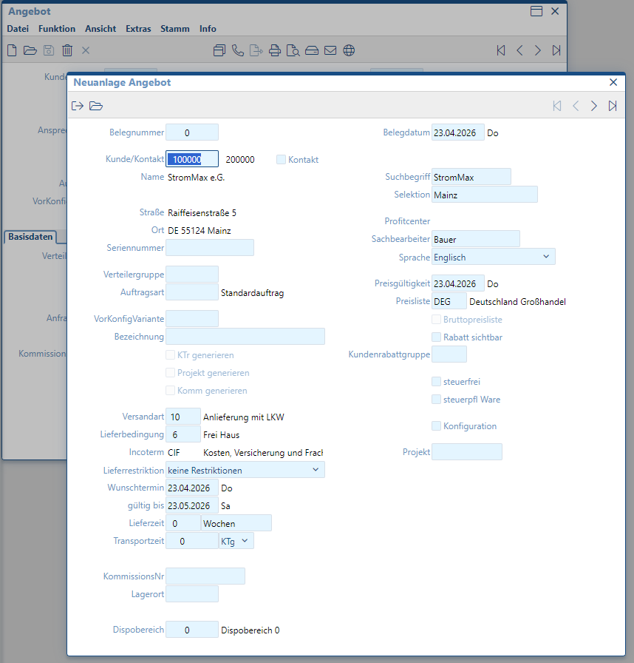
Figure 1. Create a new quotation

Step 2: Add and review quotation positions
Add the quotation positions and review the item numbers, descriptions, quantities, prices, and open quantities before continuing.
Check: All positions are complete and ready to be adopted into the next document.
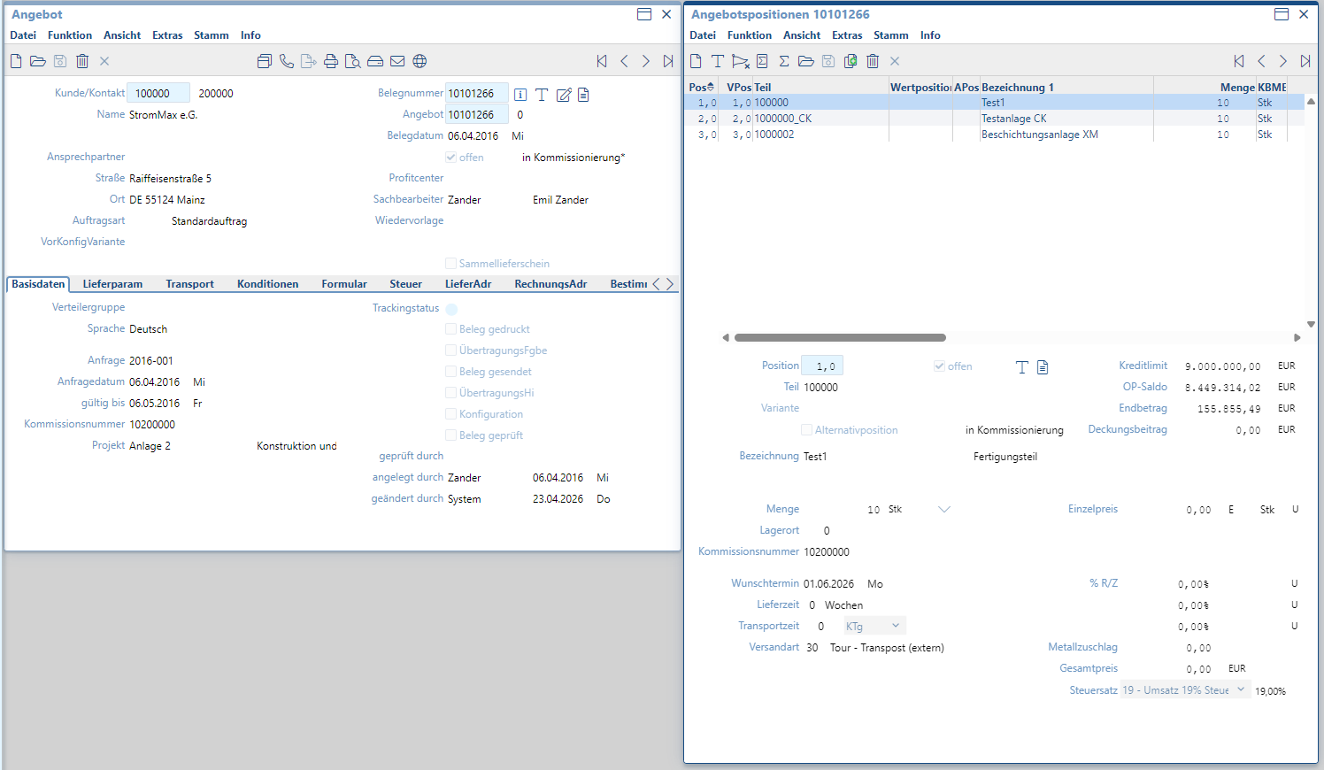
Figure 2. Add and review quotation positions

3.2 Adopt Quotation to Sales Order (A → U)
Step 3: Open document adoption
In the target document, open Extras > Belegübernahme to start document adoption from the source quotation.
Check: The adoption menu is opened from the correct target document.
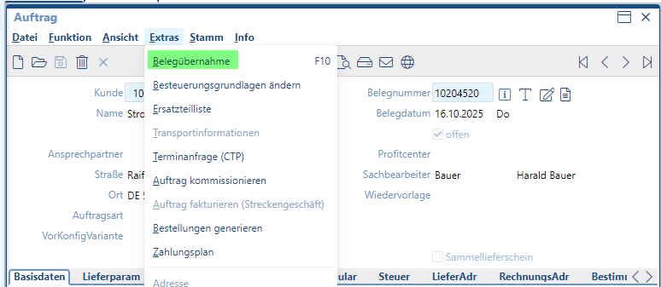
Figure 3. Open document adoption

Step 4: Filter the source quotation
Use the adoption filter to search for the correct source quotation. Typical filter fields include customer, document number, date range, profit center, and document type.
Check: The filter points to the intended quotation and avoids adopting the wrong source document.
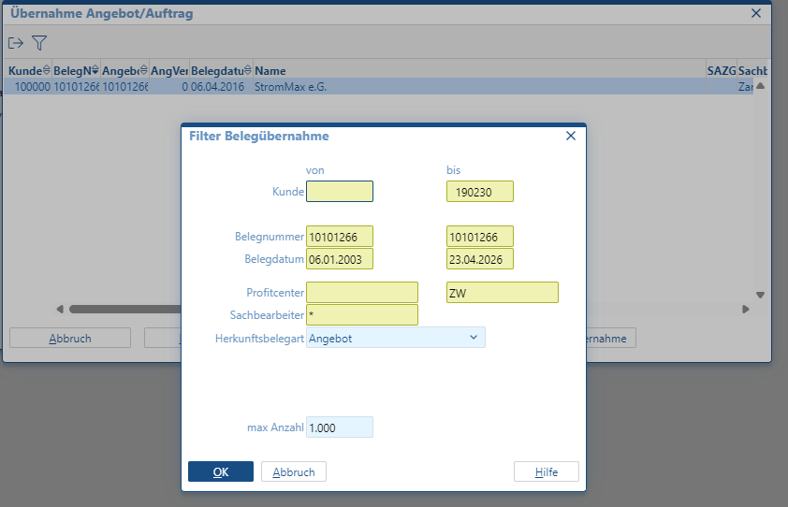
Figure 4. Filter the source quotation
Step 5: Select the source quotation
Select the source quotation. Choose Positions to adopt selected positions, or Complete Adoption to transfer the full document.
Check: Use selected positions when only part of the quotation should be adopted.
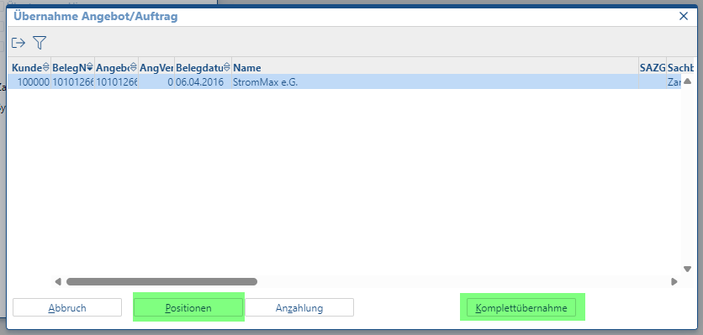
Figure 5. Select the source quotation

Step 6: Confirm positions to adopt
Review the available quotation positions and confirm which positions should be adopted into the sales order.
Check: The selected positions match the required order scope.
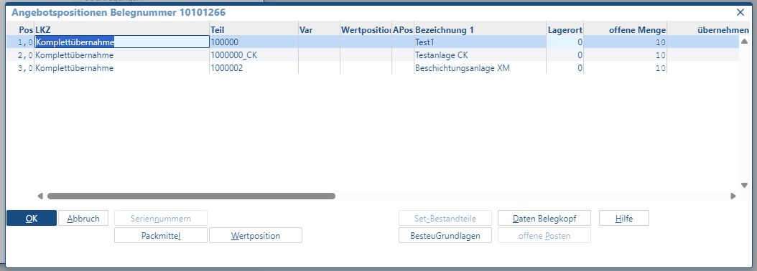
Figure 6. Confirm positions to adopt
Step 7: Choose the adoption indicator
Select the required delivery/adoption indicator, such as complete adoption, multiple adoption, or partial adoption, depending on the business process.
Check: The indicator matches the required adoption behavior.
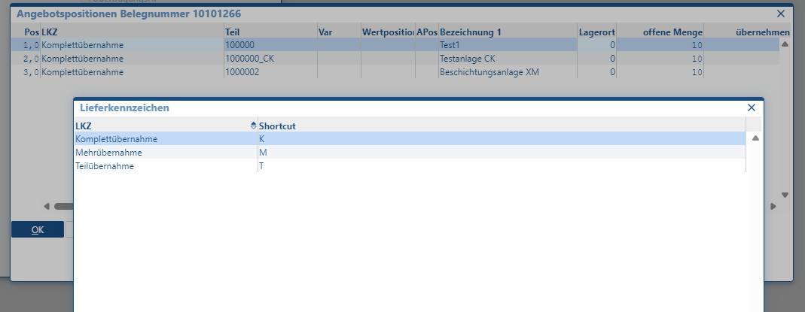
Figure 7. Choose the adoption indicator

Step 8: Verify the created sales order
The sales order (Auftrag) is created with the adopted positions. Verify the header data, item list, quantities, and open quantities.
Check: The sales order correctly references the source quotation and contains the expected positions.
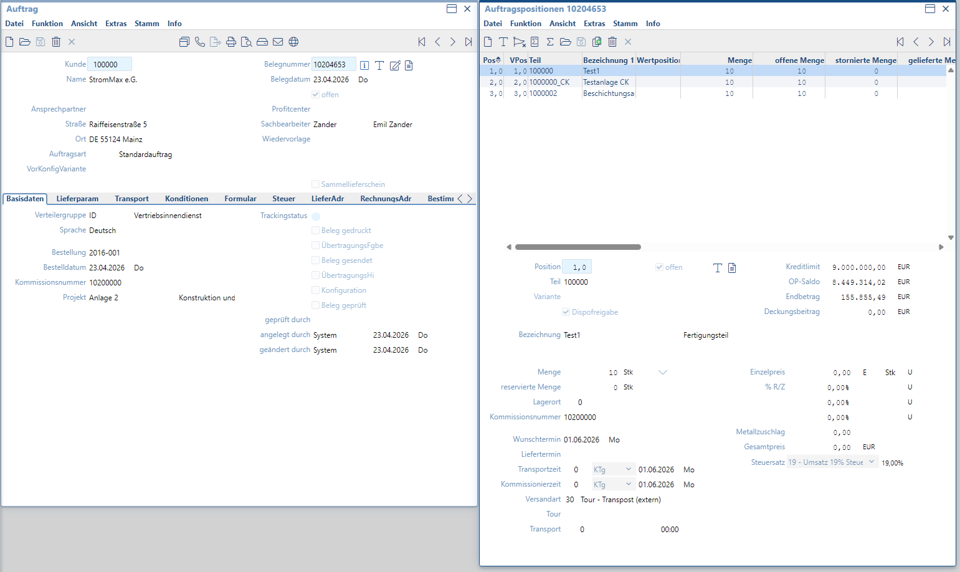
Figure 8. Verify the created sales order

3.3 Adopt Sales Order to Delivery Note (U → L)
Step 9: Open adoption in the delivery note
From the delivery note without billing, open Extras > Belegübernahme to continue the adoption process from the sales order.
Check: The delivery note is the target document and the sales order is the source document.
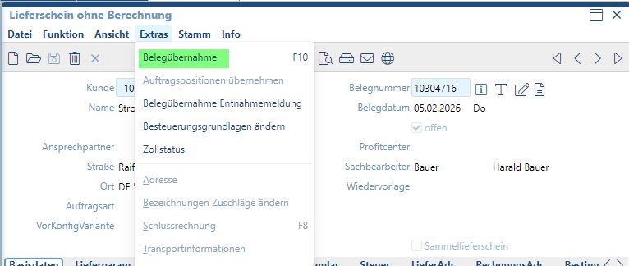
Figure 9. Open adoption in the delivery note

Step 10: Select the source sales order
Select the source order and choose whether to adopt specific positions or perform a complete adoption.
Check: Only the required order positions are transferred to the delivery note.
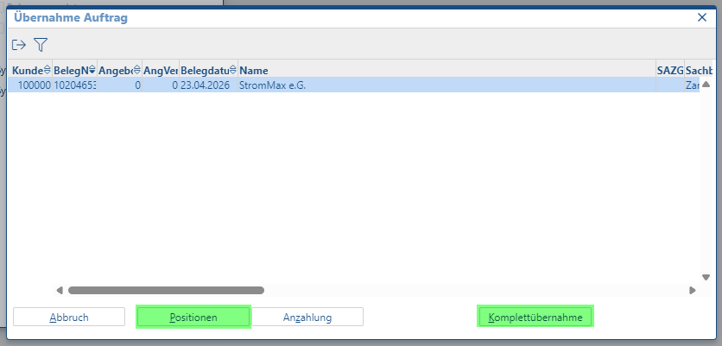
Figure 10. Select the source sales order
Step 11: Verify the delivery note
The delivery note is created with the adopted positions. Check the delivery note header, position list, storage location, quantities, and price information.
Check: The delivery note is complete and ready for the next step.
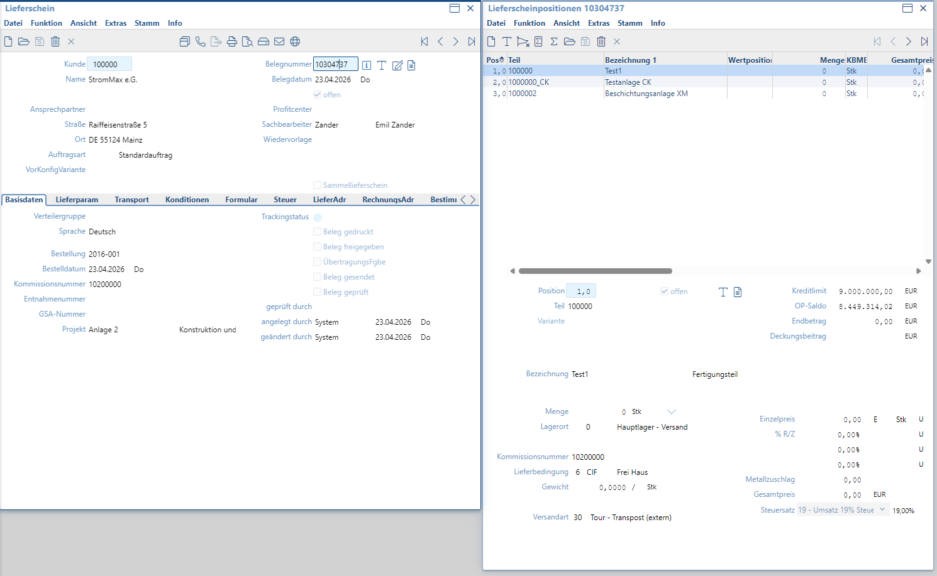
Figure 11. Verify the delivery note

3.4 Adopt Delivery Note to Invoice (L → R)
Required before this step
Print the delivery note before adopting it to the invoice. If the delivery note has not been printed, the invoice adoption may not be possible.
Step 12: Confirm the delivery note is ready
Before billing, check that the delivery note is complete and printed. This confirms that the delivery document is ready to be used as the source for invoicing.
Check: The delivery note is printed and ready for invoice adoption.
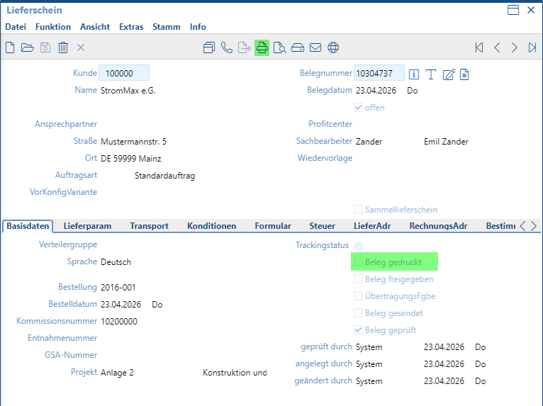
Figure 12. Confirm the delivery note is ready
Step 13: Open Faktura nach Lieferschein
Open Faktura nach Lieferschein to create an invoice based on the delivery note.
Check: Use this option when the invoice should be created from an existing delivery note.
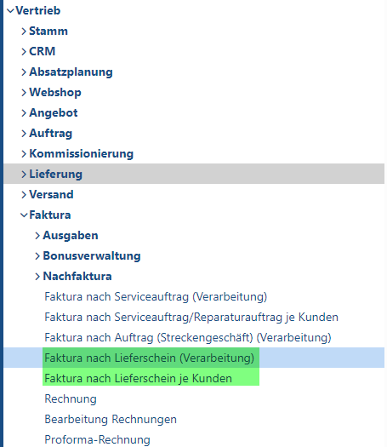
Figure 13. Open Faktura nach Lieferschein
Step 14: Enter the delivery note document number
Enter the document number (Belegnummer) of the delivery note and confirm the filter/search criteria.
Check: The selected delivery note is the correct source document for invoicing.
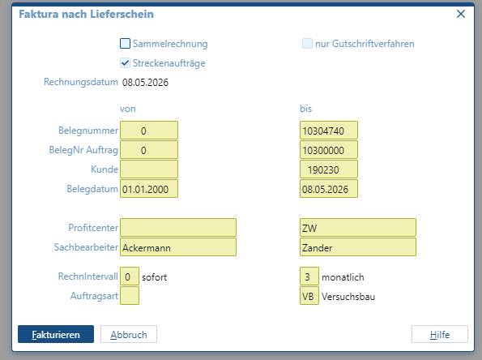
Figure 14. Enter the delivery note document number

Step 15: Verify the created invoice
The invoice (Rechnung) is created from the delivery note. Check the invoice header, positions, quantities, price information, and origin references.
Check: The invoice correctly represents the delivered positions.
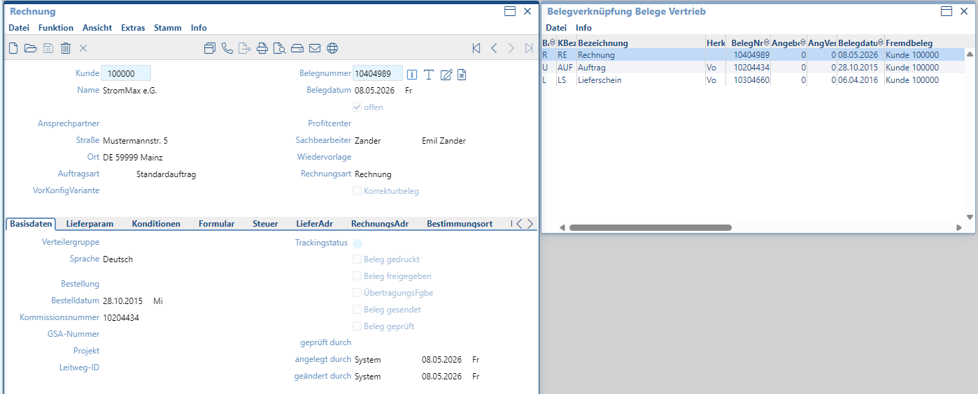
Figure 15. Verify the created invoice

4. Alternative Process: Adoption from Sales Order
In some cases, the invoice or follow-up document can also be created through document adoption from an existing sales order (Auftrag). The exact option depends on the business process and system configuration.
Step A: Open document adoption in the invoice area
In the invoice screen, open Extras > Belegübernahme to start document adoption.
Check: Confirm that the target document is the correct invoice or billing document.
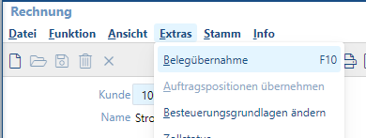
Figure A. Open document adoption in the invoice area

Step B: Filter and select the source order
Use the adoption filter to select the relevant sales order as the source document. Review the document number, customer, and source document type before adopting.
Check: The source order is correct before creating the target document.
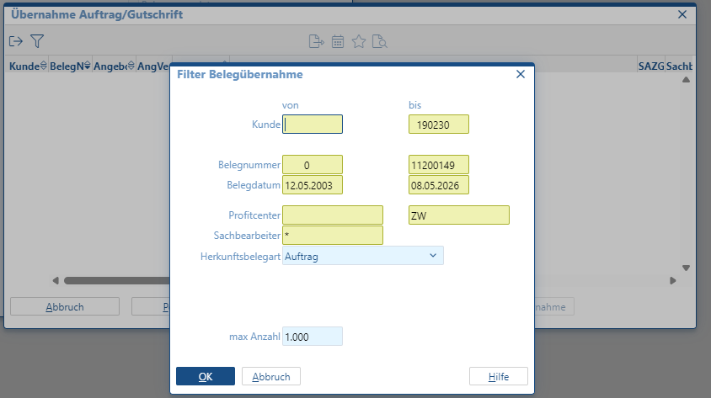
Figure B. Filter and select the source order

5. Data Linkage Summary for Developers
- Header information is stored in V_BelegKopf. Important fields include Firma, BelegArt, ReferenzNr, Belegnummer, Kunde, and Offen.
- Position information is stored in V_BelegPos. Important fields include BelegArt, ReferenzNr, PositionNr, Artikel, Menge, Preise, Offen, and Herkunft.
- When a position is adopted, the target position carries reference information back to the source position through Herkunft fields.
- For troubleshooting, start with the current document, then follow Herkunft back through the document chain.

